OSSP (Operating Systems And Systems Programming) - 25CS2104E

PRACTICAL
- Develop a C program that demonstrates how a Linux operating system executes a command entered by a user that 1. Accept a Linux command as input. 2. Create a child process using fork(). 3. Execute the command in the child process using an appropriate exec() system call. 4. Allow the parent process to wait for the child using wait (). 5. Display the Process ID (PID) of both parent and child processes.

Using Linux terminal commands (uname, lscpu, lsblk, ps, top), investigate the relationship between hardware resources and operating system services. Prepare a report explaining how the OS abstracts CPU, memory, storage, and I/O devices.
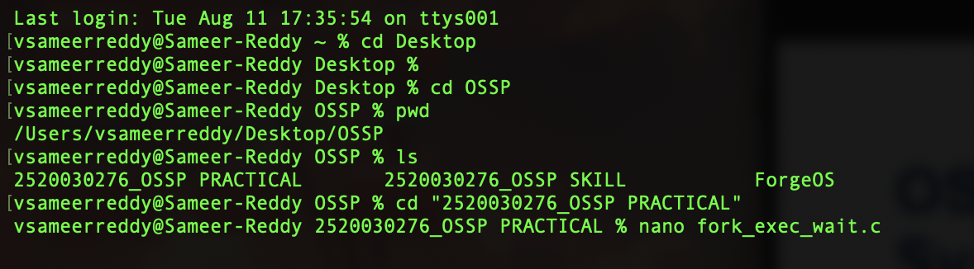
STEP 1 - CREATE THE C PROGRAM

STEP 2 -Type The C CODE PROGRAM

#include <stdio.h>
#include <stdlib.h>
#include <unistd.h>
#include <sys/types.h>
#include <sys/wait.h>

int main()
{
char command[100];

printf("Enter a command: ");
scanf("%s", command);

pid_t pid = fork();

if (pid < 0)
{
printf("Fork failed\n");
return 1;
}

if (pid == 0)
{
printf("Child Process PID: %d\n", getpid());
printf("Child is executing the command...\n");

execlp(command, command, (char *)NULL);

printf("Exec failed\n");
exit(1);
}
else
{
printf("Parent Process PID: %d\n", getpid());
printf("Parent is waiting for child...\n");

wait(NULL);

printf("Child process completed.\n");
}

return 0;
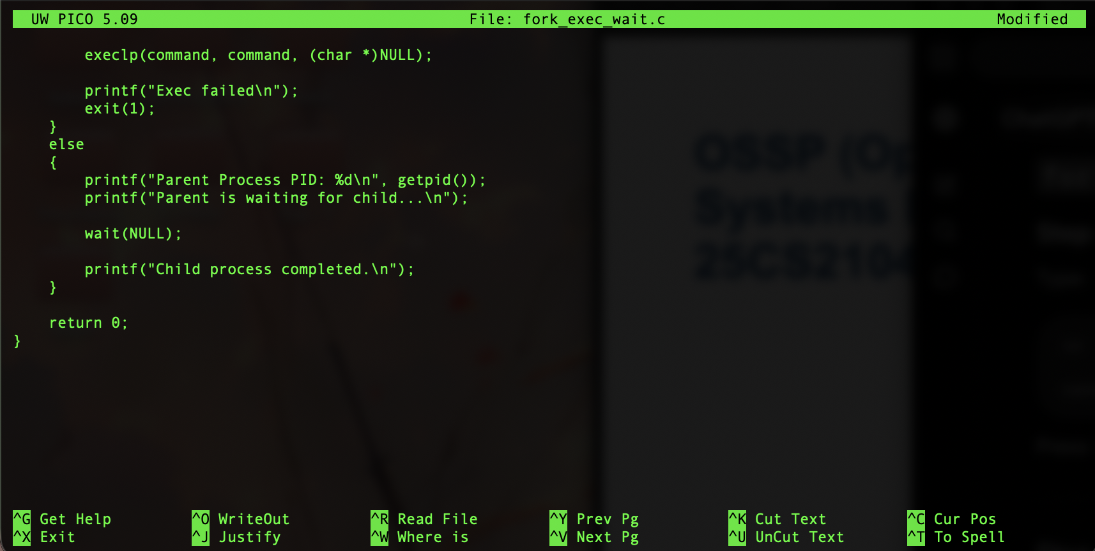
}

STEP 3 - SAVE THE PROGRAM

Control + O
Enter
Control + X
You will return to terminal

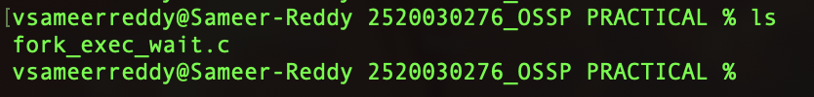
STEP 4 - CHECK THE C FILE

STEP 5 - COMPILE

STEP 6 - RUN

YOU WILL SEE
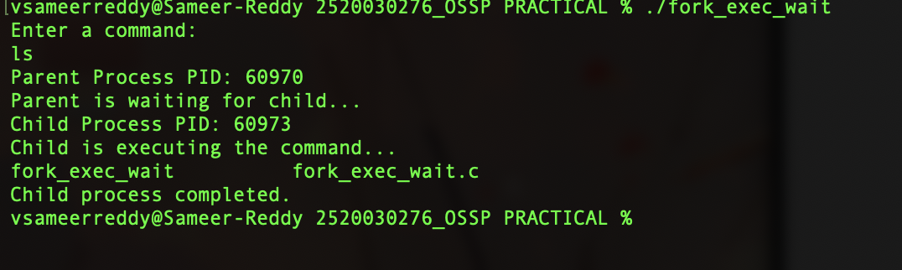
Enter a command: ls
STEP 7 - TRY date

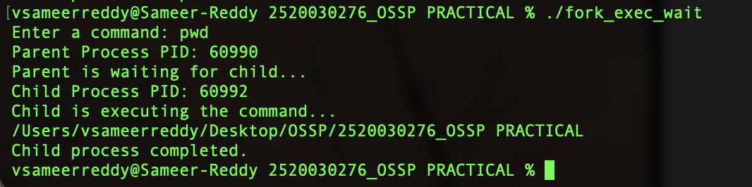
Run agian : ./fork_exec_wait


STEP 8 - TRY pwd

STEP 9 - CHECK OS
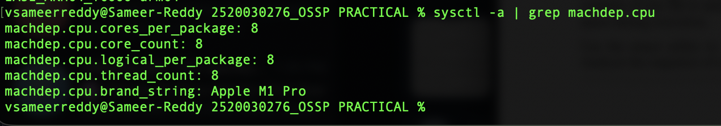
STEP 10 - CHECK CPU INFORMATION

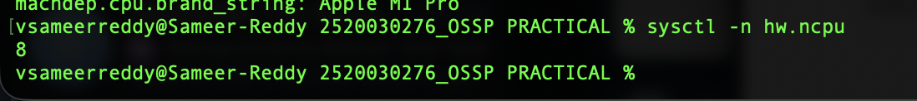
STEP 11 - CHECK NUMBER OF CPU CORES

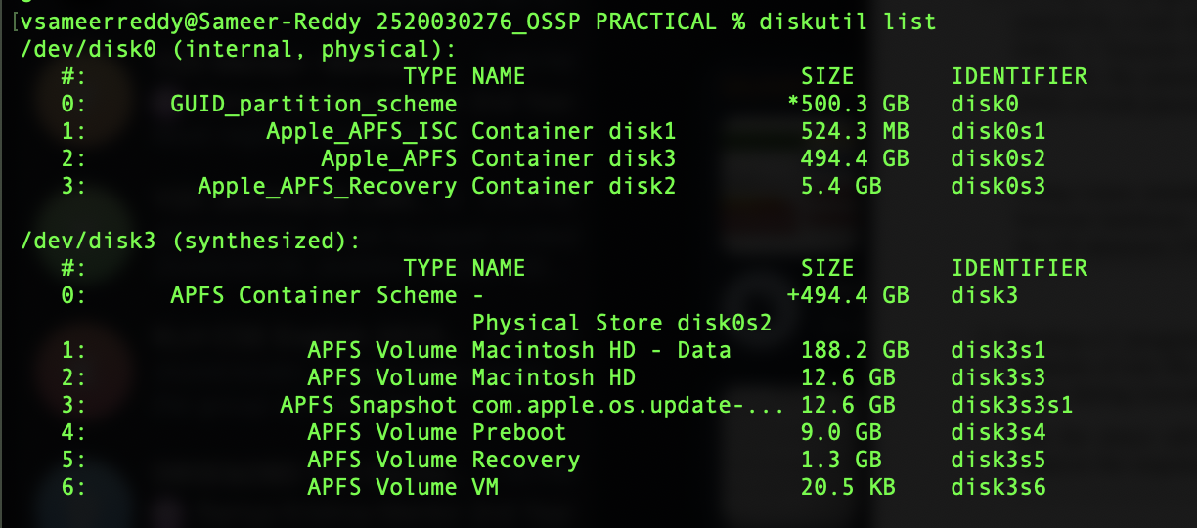
STEP 12 - STRORAGE INFORMATION

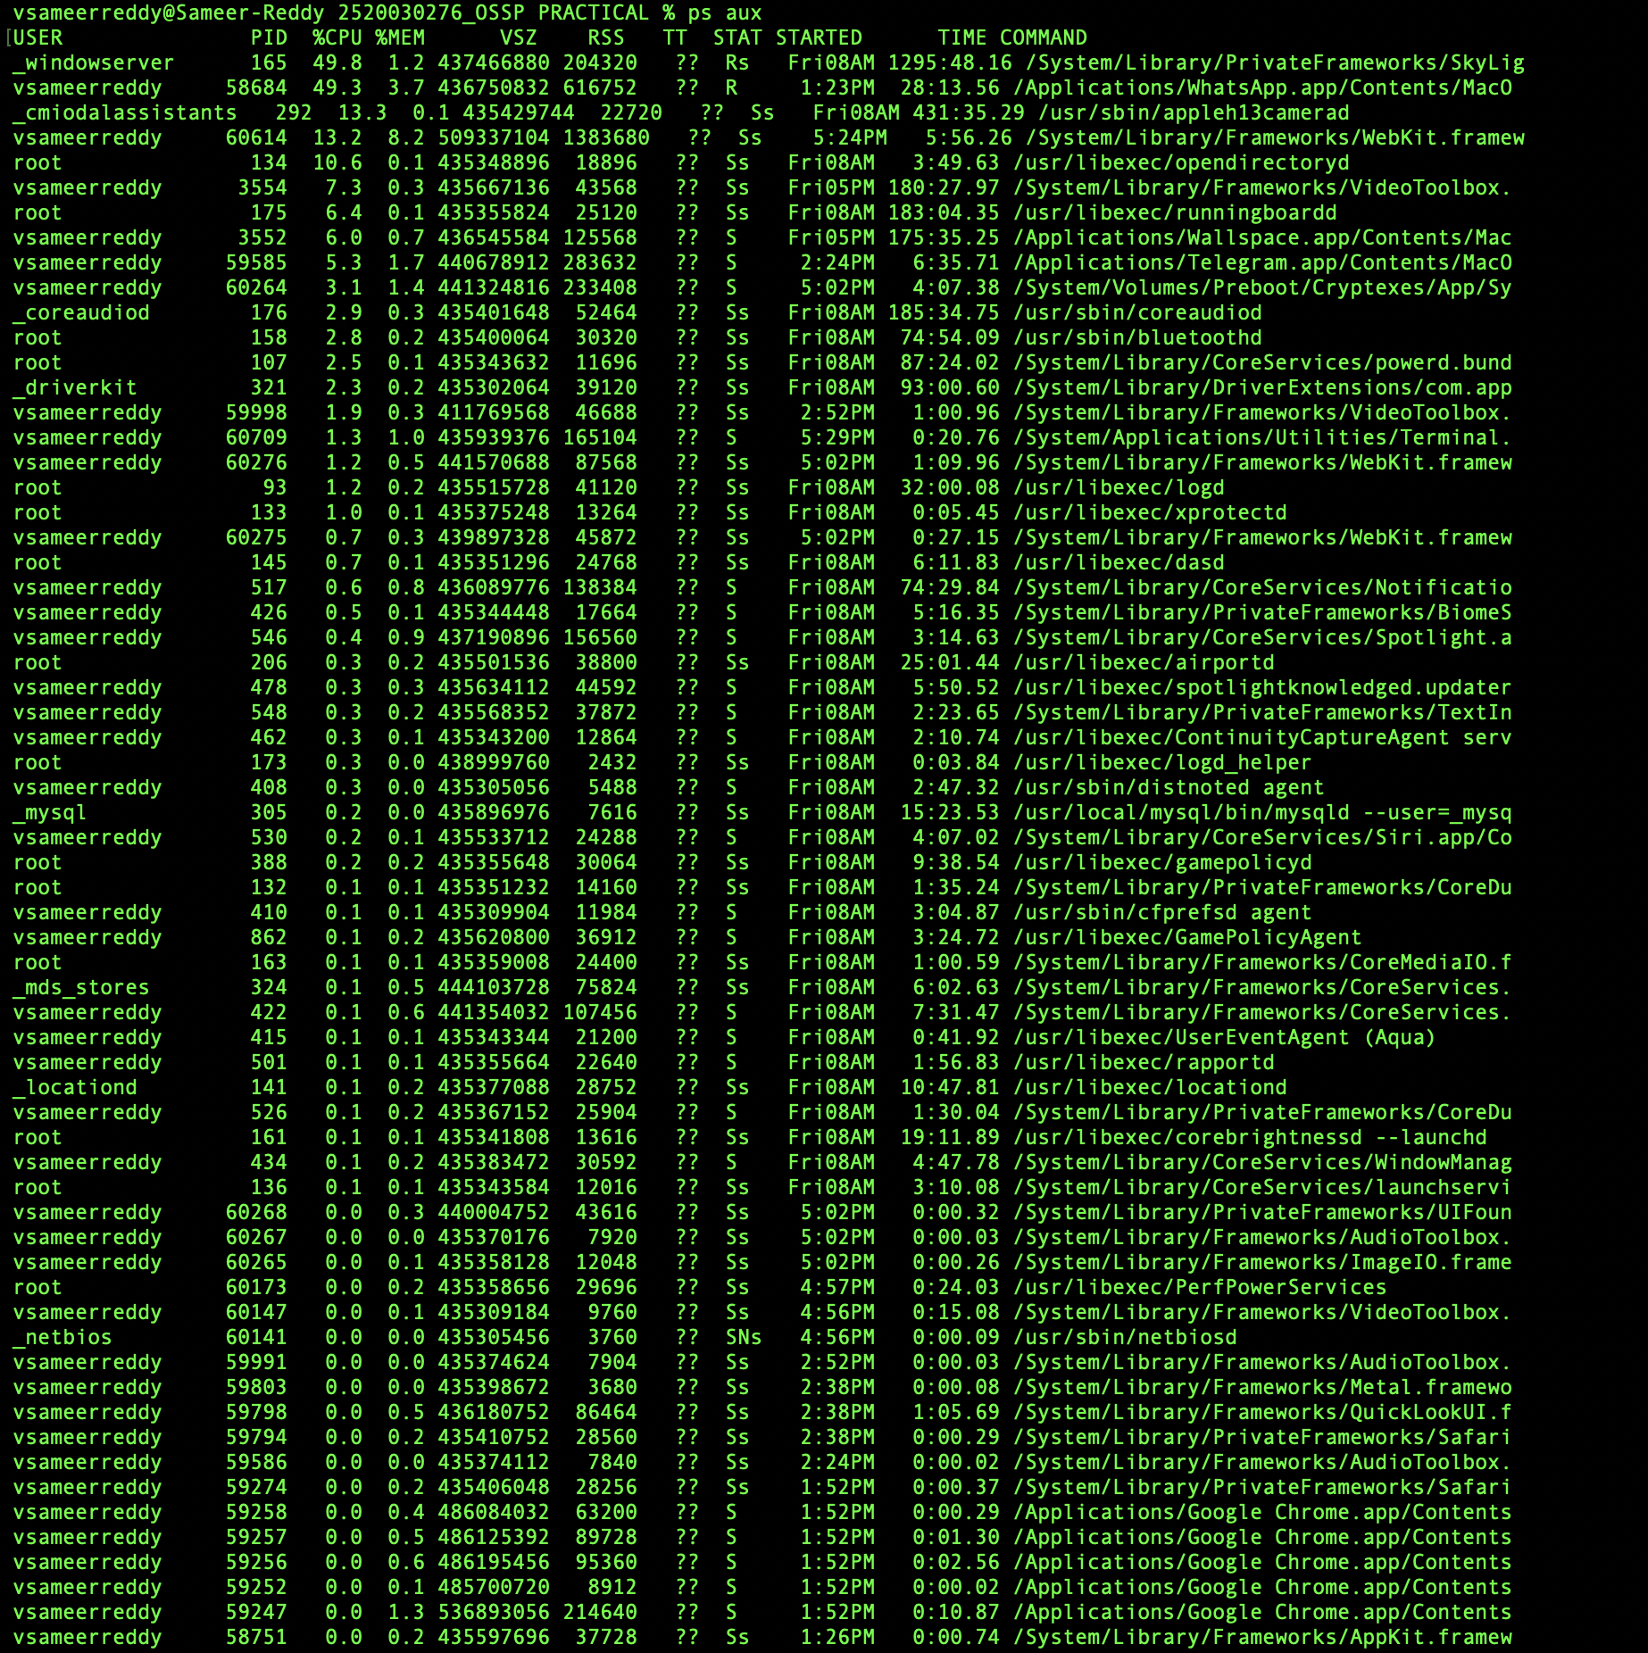
STEP 5 - CHECK PROCESSES

STEP 6 - PROCESS MONITORING

